**Exercise**

1. Git Setup<https://confluence.atlassian.com/bitbucket/set-up-git-744723531.html>





[](https://confluence.atlassian.com/bitbucket/set-up-git-744723531.html)

1. [Initialize a Git Repository](https://confluence.atlassian.com/bitbucket/set-up-git-744723531.html)





1. Add files to the repository



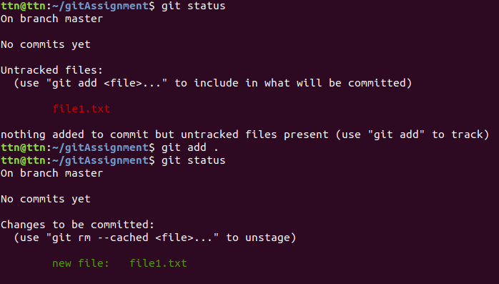

1. Unstage 1 file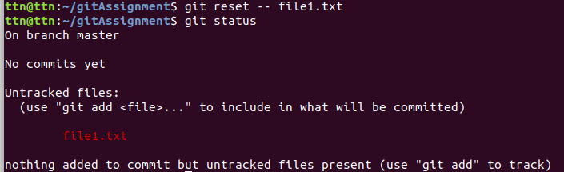
2. Commit the file

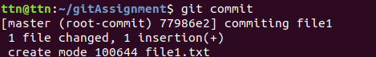

1. Add a remote



1. Undo changes to a particular file

**Undo changes to a particular file (Before Commit)**

File1 content before using stash:



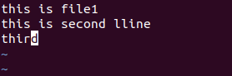

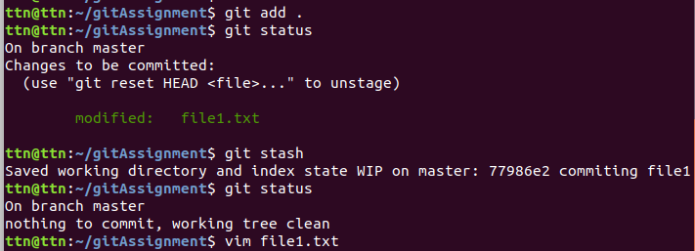

File1 content after using stash:



**Undo changes to a particular file (After Commit)**

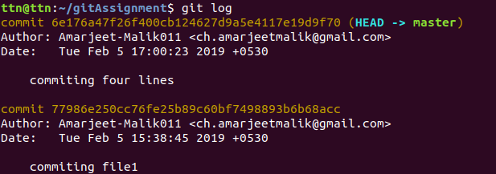



1. Push changes to Github

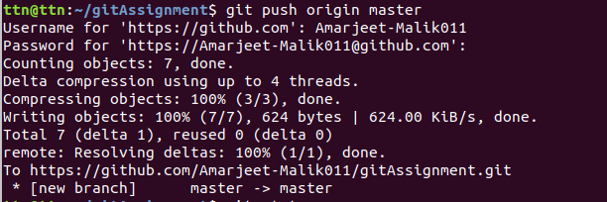

1. Clone the repository

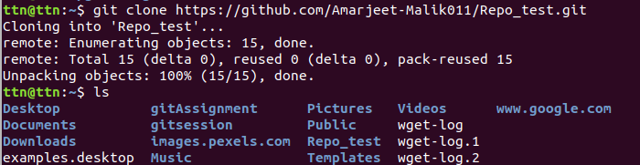

1. Add changes to one of the copies and pull the changes in the other.

// making another clone repo

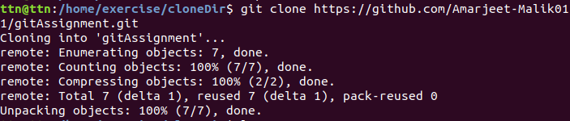

//making changes in file via clone repo

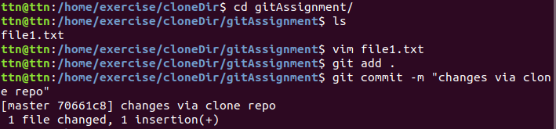

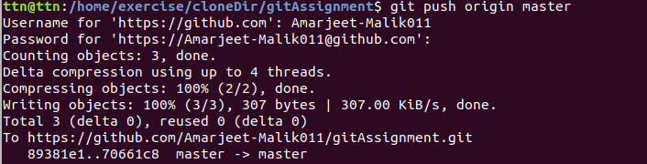

//adding change to the first repo, that are made in clone repo

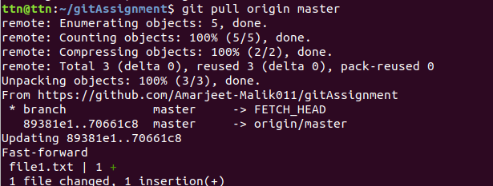

1. Check differences between a file and its staged version

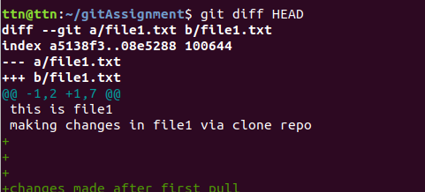

1. Ignore a few files to be checked in



//editing file2.txt name in gitignore file



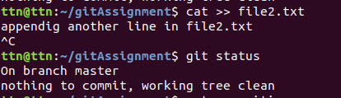

1. Create a new branch.

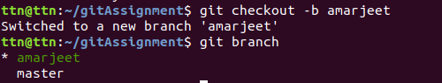

1. Diverge them with commits

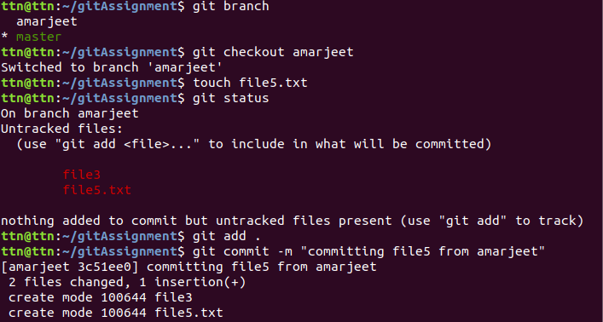

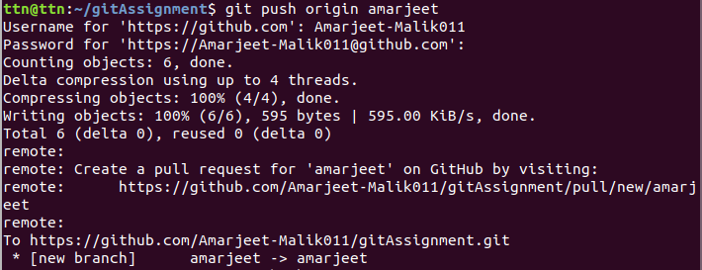

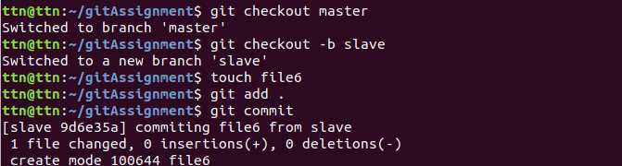

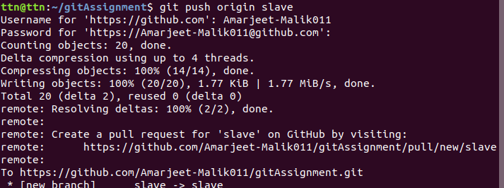

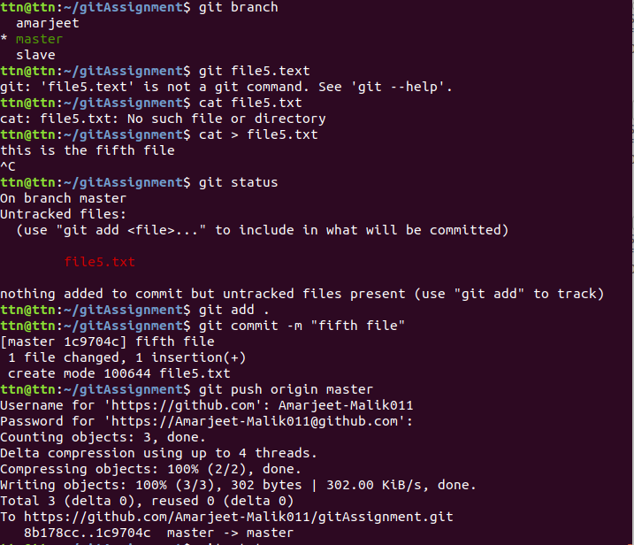

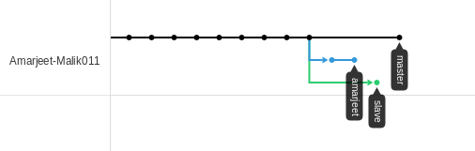

1. Edit the same file at the same line on both branches and commit

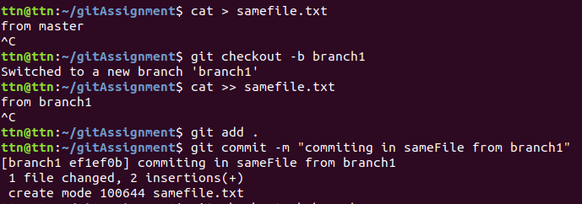

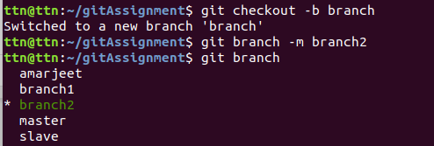

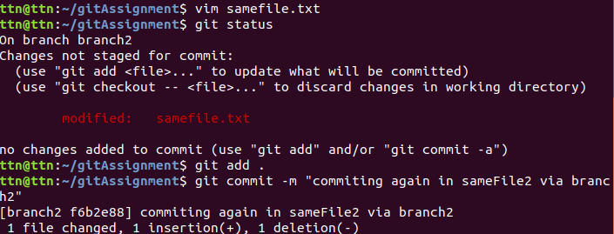

1. Try merging and resolve merge conflicts

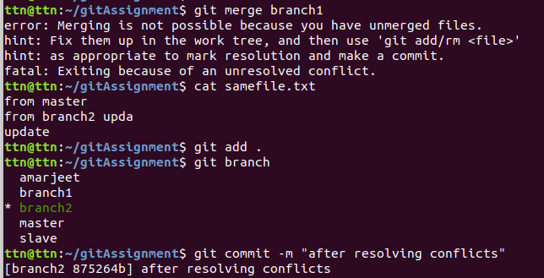

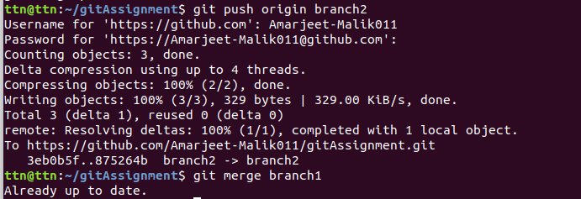

1. Stash the changes and pop them

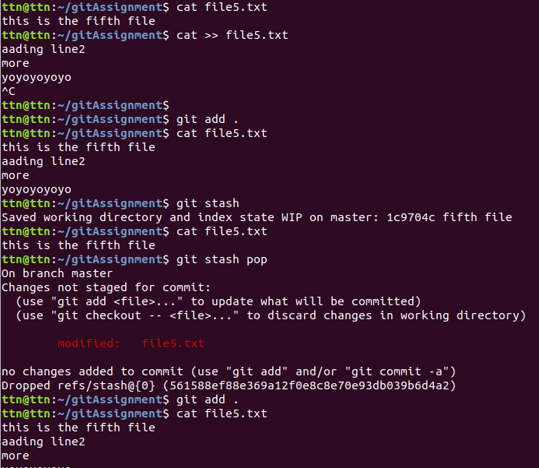

1. Add the following code to your .bashrc file : color_prompt="yes"  
    parse_git_branch() {  
    git branch 2> /dev/null | sed -e '/^[^*]/d' -e 's/* \(.*\)/(\1)/'  
    }  
    if [ "$color_prompt" = yes ]; then  
    PS1='\u@\h\[\033[00m\]:\[\033[01;34m\]\W\[\033[01;31m\] $(parse_git_branch)\[\033[00m\]\$ '  
    else  
    PS1='\u@\h:\W $(parse_git_branch)\$ '  
    fi  
    unset color_prompt force_color_prompt

